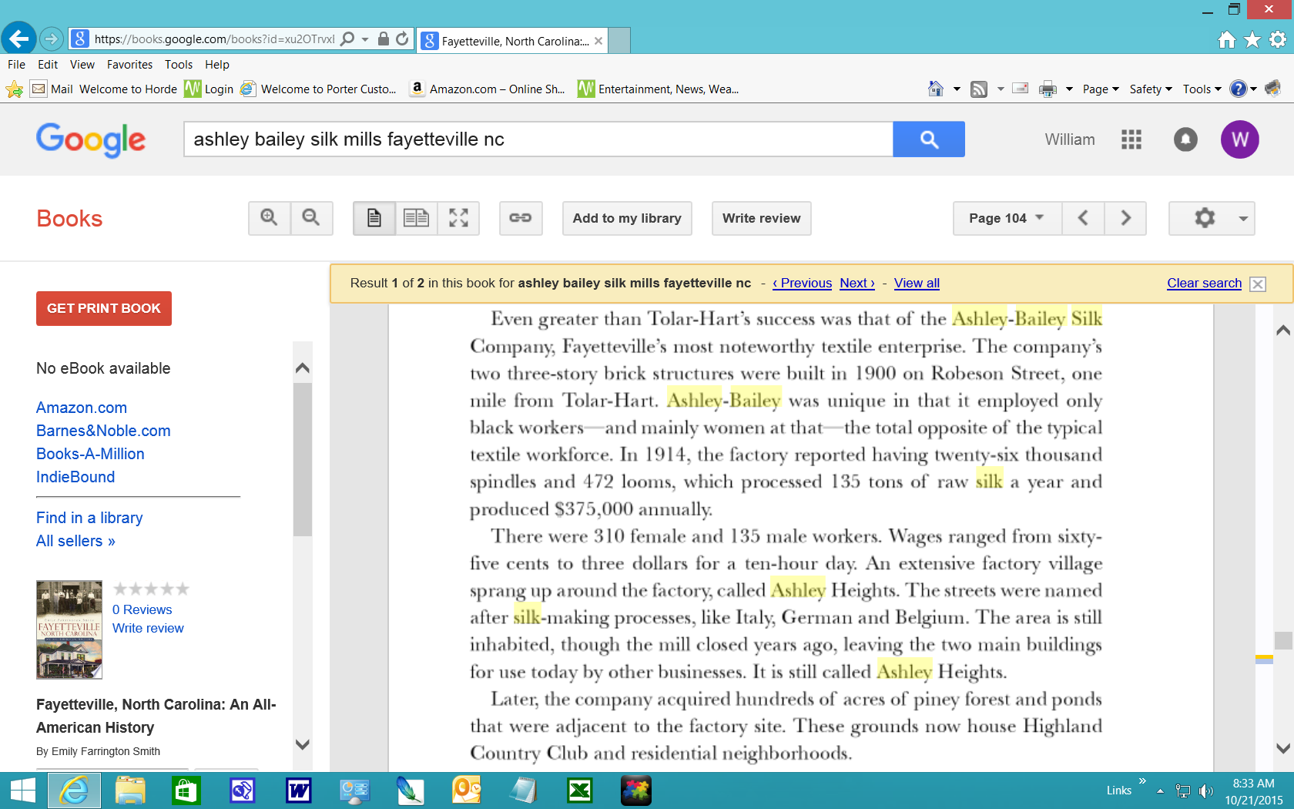

From the Book Fayetteville, North Carolina: An All-American History. By Emily Farrington Smith

TEXTILE INDUSTRY BOUNCED BACK FROM WAR'S DESTRUCTION

Posted: Friday, November 17, 1989 12:00 am | Updated: 11:27 am, Fri Dec 13, 2013. From fayobserver.com

The most singular textile enterprise was the silk-weaving factory, also built in 1900, a mile away from Tolar-Hart on Robeson Street. The two three-story brick structures of the Ashley-Bailey Silk Co. were of the latest modern design.
The operation was unique because it hired only black workers, mostly women, in a day when the textile work force was otherwise all white.
The Philadelphia firm was convinced from its operations in Patterson, N.J., that black workers were best able to manipulate the slinky product of their looms. And, as a newspaper report on the factory said: "Climatic conditions in the South and cheap labor is greatly in favor of the South for silk mills."
T.W.Thurston, the superintendent of the factory, was dispatched from the parent factory. Thurston was "himself a colored man," reported The Fayetteville Observer, "a native of Pennsylvania, was educated for an Episcopal clergyman, and is very courteous and polite ... he is alert, businesslike, and knows his business."
The white editor concluded: "Colored mill operatives is an experiment and the management of this silk mill seem satisfied with the result."
The move was an early instance of a pattern that became familiar later, the flight of northern manufacturing to the low-wage south.
In addition to labor willing to work for low wages and the climate, the abundance of railroads made transportation convenient for operations linking the manufacturing expertise and capital of the Philadelphia area to Fayetteville's supply of willing workers and its Dixie climate.
An extensive factory village sprang up on "Ashley Heights" around the plants, with street names like "Italy," "Belgium" and "German" (all silk-making processes), as well as "Silk Lane." The company bought hundreds of acres of adjoining pine woods and ponds. Today, these rolling acres are Fayetteville's most exclusive country club and residential neighborhoods.

