BCCI FIRING RANGE SAFETY ISSUES

Today April 20, 2004, the following pictures were taken at Brown Creek Correctional Institution’s firing range while prepping the range prior to The Division of Community Corrections usage. Most of the firing range safety issues have been prior addressed in an email dated September 1, 2003 but I believe the following pictures speak for themselves.

The following is a picture of our range backstop berm which is approximately eight (8) feet in height and is not doing a 100 percent job of stopping any rounds fired high or rounds that ricochet from the back stop itself or ricocheted from a hit in front of the berm.
The backstop has suffered much erosion over the past year and also by the extreme amount of usage by other facilities and agencies. There are at least two to three feet of dirt missing from the berm and rocks are exposed which help promulgate a ricochet.

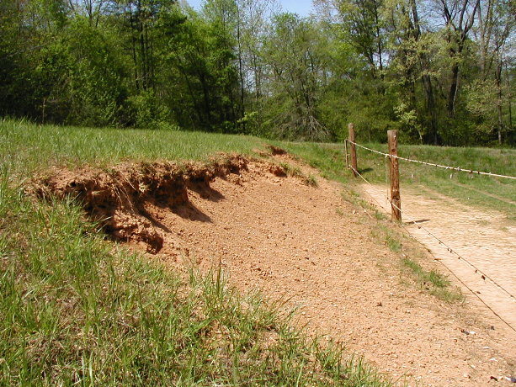

The range backstop berm is the first line of defense in containing rounds fired and the following pictures will show that it is failing very badly. One round that escapes the backstop berm is one potential accident in the making. The following pictures of bullets that have gone over the backstop berm and ricocheting off trees either by a ricochet or by an employee firing high will manifest itself to the seriousness of the hazards present.
Bullet holes were present directly behind the backstop berm and were present from a distance in the tree and bush growth from 10 yards to 45 yards. I did not go any further to look for bullet holes in the trees and bullet hole ricochets. At a distance of about 45 yards from the berm, the tree damage from the bullets was approximately 12 to 15 feet in height above the berm. This elevation makes an ideal situation for the bullet to travel out of the tree growth and if the angle of forty-five degrees is met, will land in the middle of Lanesboro Correctional Institution depending on the trajectory path.

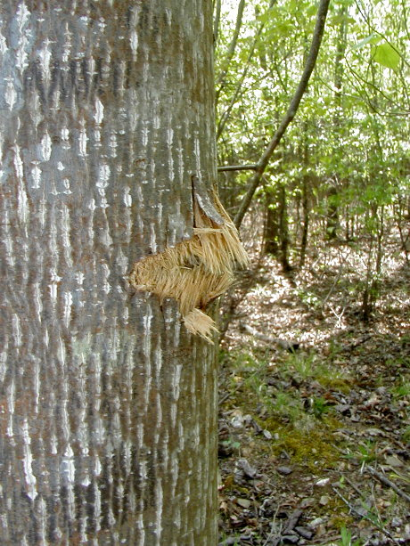

Bullet holes and bullet ricochets were present behind lane 1 thru lane 12 and I will insert some pictures. They were at different heights ranging from a couple feet to five feet off the ground.
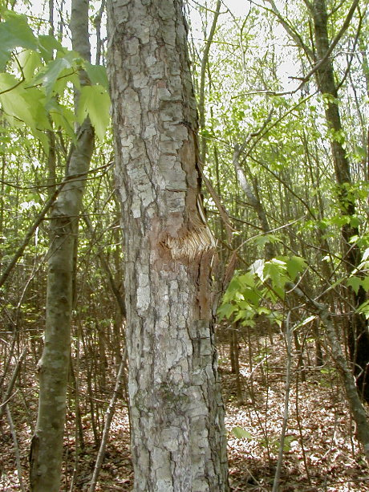

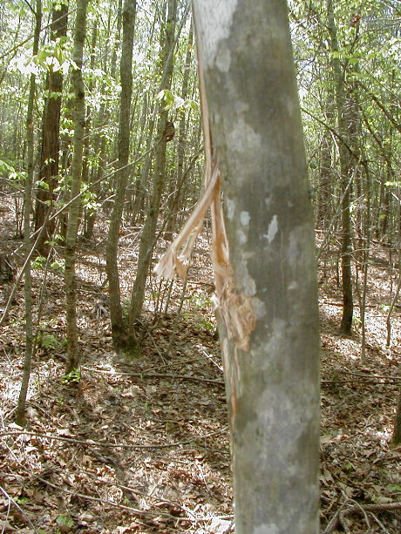

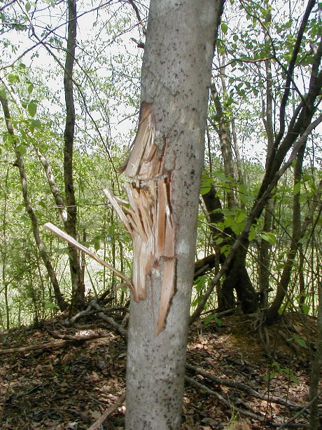

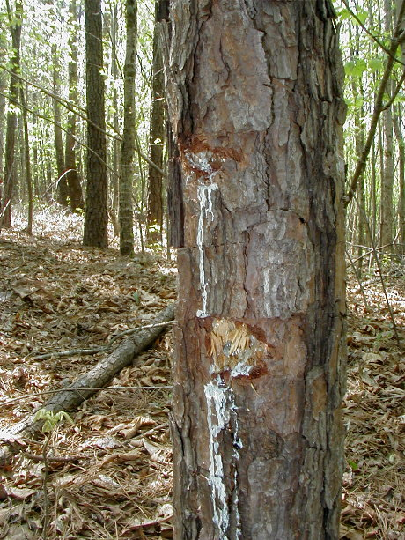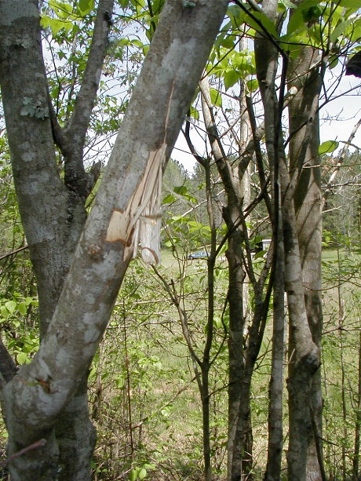

This picture gives an approximate position of the elevation, which is about 12 to 15 feet above the berm, which is approximately 45 yards from this bullet ricochet. I do not believe the elevation limit devices will work because a round fired high will still be able to go over the low eight (8) ft. berm and also there is evidence of some of the bullet holes being .38 caliber which are fired from the 25 yard line to the 3 yard line.

The only solution to this problem is to increase the backstop berm height.

If it were my call, I would cease all range activity until the backstop berm meets the minimum requirements of twenty (20) feet in height with a forty-five (45) degree slope.

Submitted by William McKnight Porter 04-20-04 by email to Wanda Steele and copied to Mr. Rick Jackson and H. Jackson.

